 | CIVIC CoaliTION FOR FREE AND FAIR ELECTIONS
 | Str. Bucureşti nr. 83, Chişinău, tel: 233947; 233948, e-mail: mgodea@contact.md

 |  |  | 

Monitoring
of mass media in the electoral campaign

Report no. 2
16 January – 13 February 2005

This project was made possible with the financial support provided by the U.S. and British Embassies in Chisinau,
the United States Agency for International Development (USAID)
and the Swedish International Development Cooperation Agency (Sida)
The Eurasia Foundation will be administering the USAID and Sida funds for this project.

The views and opinions expressed in this publication do not necessarily represent those of the funding organizations.

 |  |  | British Embassy  Chisinau   | 

Monitoring of Mass Media in the electoral campaign
Report no. 2, 16 January -13 February 2005

The Project for the monitoring of how Moldovan mass media cover the parliamentary electoral campaign aims at informing the public opinion about the behavior of the press in the electoral campaign and at drawing the attention of the international community to cases of abuse against press freedom in the electoral process.

The Project is implemented within the “Coalition 2005” by the Independent Journalism Center, Center for Analysis and Sociological, Political and Psychological Investigations CIVIS, Association of Independent Press and the international organization Global Campaign for Freedom of Speech “Article 19”.

General conclusions

Electronic press
As in the first two monitoring weeks, most radio and TV stations, both public and private, subject to the monitoring maintained the tendency of favoring the governing party and disfavoring the opposition, except for one radio and one TV station – Antena C and Euro TV, whose manner of coverage of the electoral campaign showed an unbalance in disfavor of PCRM (Communist Party of Moldova). Several private radio and TV stations, included in the list of monitored institutions, practically do not broadcast electoral subjects. All national coverage radio and TV stations (except Hit FM) favored the governing party and disfavored the opposition.

As for the public stations with national coverage Moldova 1 and Radio Moldova, as sources of electoral information, we attested a discrimination of opposition parties. It should be mentioned that Radio Moldova covers the electoral campaign in a more balanced way as compared to the TV station Moldova 1. The regional public company Teleradio Găgăuzia ignored the opposition parties.

Print media
At the second monitoring stage, we noted a clearer delimitation between electoral articles and advertising on the one hand, and the rest of materials on the other.

Public (state) press continued to favor in an obvious way the governing party, ignoring or presenting in a negative context the main opposition parties or electoral blocs. Public newspapers “abounded” in praising articles about the “economic and social achievements of the past four years” of the governing party.

Private media either favored electoral competitors other than the governing party, or did not show sympathy for any of the competitors.

Monitoring results

TV

The largest amount of electoral news was broadcast by NIT (25 percent), Moldova 1 (20 percent), Euro TV Chişinău (15 percent), RIF (12 percent) (Diagrams 1-2)

Diagram 1. Share of monitored stations in broadcasting electoral news
- Frequency
Euro TV
15%
Moldova 1
20%
NIT
25%
RIF
12%
Pro TV
6%
Pervii Canal
7%
TV Gagauzia
5%
TV Balti
1%
TV 21
7%
Blue Star TV
2%

Diagram 2. Share of monitored stations in broadcasting
electoral news - Duration
Blue Star TV
2%
TV 21
6%
TV Balti
1%
TV Gagauzia
7%
Pervii Canal
5%
Pro TV
7%
RIF
9%
NIT
26%
Moldova 1
18%
Euro TV
19%
News favoring the electoral competitors

The most widely covered electoral competitor in news with positive content and/or context was the governing party. Only one TV station favored mainly BMD (Democratic Moldova Bloc) and PSDM (Social Democratic Party of Moldova), while PRO TV, TV Bălţi and Blue Star showed in the past two weeks of monitoring a tendency towards a balanced coverage of the competitors. (Diagrams 3-4)

The public stations Moldova 1 and TV Găgăuzia obviously favored the governing party – PCRM: 75.3 percent of the favorable news on Moldova 1, and 100 percent (31 of 31 pieces of news) on TV Găgăuzia.

We noted a tendency towards a more balanced coverage on Euro TV Chişinău. BMD benefited from the most positive news (34.9 percent), but other electoral competitors were favored as well: PSDM -20.9 percent, PPCD (Popular Christian Democratic Party) and PCRM – 9.3 percent each.

TV Bălţi broadcast a small amount of electoral news and did not favor any candidate.

The share of news favoring the electoral competitors: Moldova 1 – 27.2 percent, Euro TV – 18.4 percent, TV Găgăuzia – 50 percent.

Most private stations favored the governing party. In this regard, we noted NIT (100 percent), Pervîi kanal v Moldove (100 percent), RIF (83.3 percent), TV 21 (71.2 percent). A balanced coverage was registered at PRO TV and Blue Star (Diagrams 3-4).

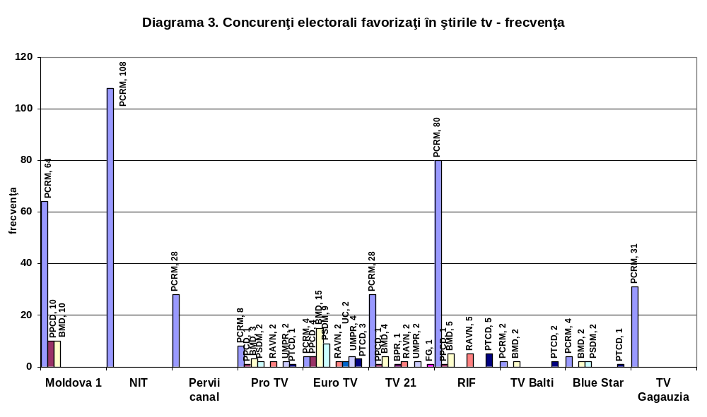

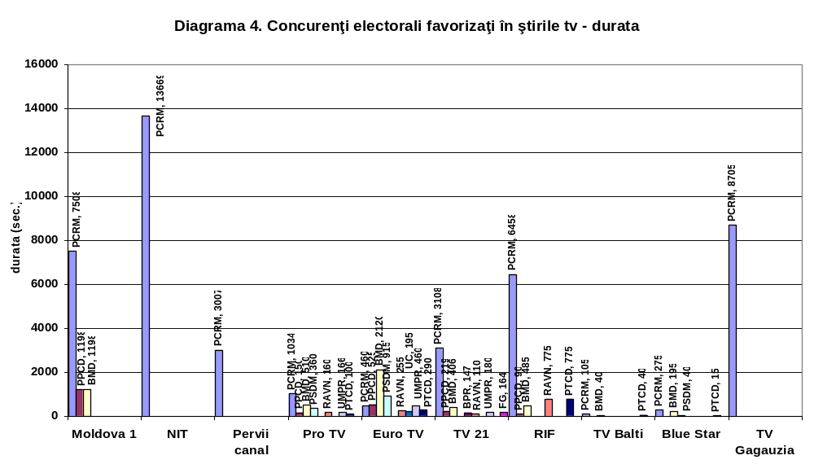

News disfavoring the electoral competitors

On most monitored stations, the subject of most disfavoring news remained the opposition, especially BMD, PPCD and PSDM. Most news with negative content or context about PCRM was broadcast by Euro TV. (Diagrams 5-6).

Moldova 1 was especially critical of BMD, and broadcast only one piece of critical news about PCRM. The ratio of news disfavoring the opposition and the power was 24 to 1. This ratio was reversed on Euro TV, 6 to 47, in the disfavor of state authorities. TV Bălţi and TV Găgăuzia did not broadcast critical news either about state authorities, or opposition parties.

NIT, Pervîi kanal, TV 21, RIF, Blue Star disfavored the opposition most of the times. In the past two weeks of monitoring, PRO TV did not broadcast any news disfavoring any electoral competitor.

It should be mentioned that all national coverage stations favored the governing party: Moldova 1, NIT, Pervîi kanal v Moldove.

Euro TV Chişinău was the only TV station favoring opposition parties, especially BMD; it covers only about 1/3 of Moldova’s territory (Diagrams 5-6).

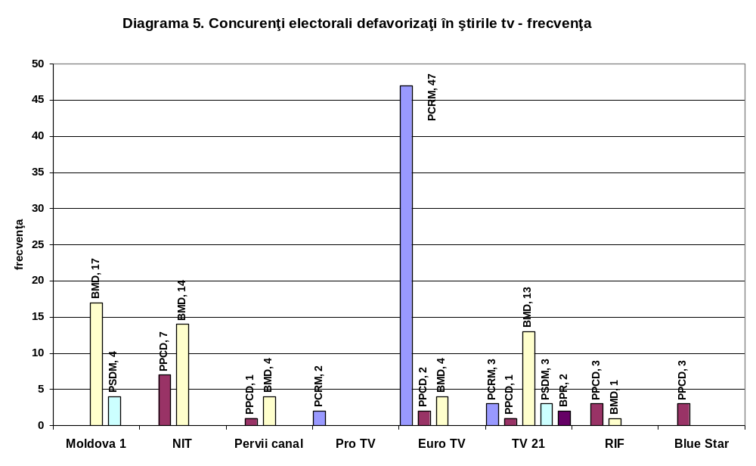

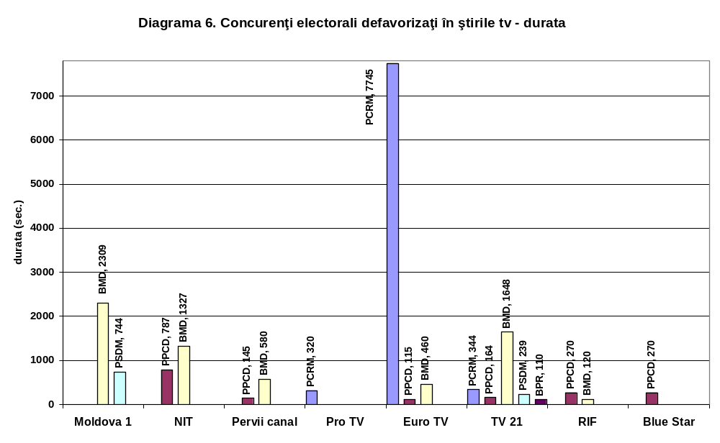

Special electoral programs

In the present monitoring period, Moldova 1 and Euro TV organized debates and interviews on electoral subjects (Diagrams 7-8).

Diagram 7. Special electoral programs (debates, interviews) -
Frequency
Moldova 1
75%
Euro TV
25%
Diagram 8. Special electoral programs (debates, interviews) -
Duration
Euro TV
39%
Moldova 1
61%
Voter education materials

Of the monitored TV stations, the most active ones in broadcasting voter education materials were Euro TV Chişinău (52 percent), NIT (32 percent) and Moldova 1 (13 percent) (Diagrams 9-10).

Diagram 9. Voter education – Frequency
Moldova 1
13%
Blue Star TV (TV6)
1%
Euro TV
52%
Pro TV
2%
NIT
32%
Diagram 10. Voter education - Duration
Moldova 1
40,8%
Blue Star TV (TV6)
0,2%
Euro TV
51,3%
Pro TV
0,3%
NIT
7,4%

Table 1. Number of sources within electoral news (%)

 | 1 source | 2 and more sources
Moldova 1 | 58 | 42
NIT | 55 | 45
Pervîi canal | 71 | 29
Pro TV | 60 | 41
Euro TV | 54 | 46
TVC 21 | 67 | 33
RIF | 70 | 30
TV Bălţi | 100 | -
Blue Star – TV6 | 85 | 15
TV Găgăuzia | 46 | 54

Sources used in electoral news

The most widely used sources in electoral news broadcast by the public station Moldova 1 were the president, ministries and government officials (28.5 percent), followed by CEC (Central Electoral Commission) (16.7 percent), foreign diplomats and officials (12.2 percent). BMD and PPCD were quoted 17 (3.8 percent) and, respectively, 6 (1.6 percent) times, while PSDM – not a single time (Table 2.).

We noted a quasi-uniform selection of sources on Euro TV. Most references were made to citizens (11.7 percent), CEC (9.8 percent), mass media (9.8 percent), BMD (9.1 percent), experts (8.6 percent), local public administration (8.1 percent). PCRM was quoted in 4.4 percent of cases, the President, ministers and government officials – 3.2 percent, PSDM – 3.7 percent, PPCD – 1.7 percent.

The public stations TV Bălţi and TV Găgăuzia did not make any references to the opposition.

On the private stations NIT, Pervîi canal v Moldove and RIF the most referred to sources were the President, ministers and government officials – 36.4 percent, 37.4 percent, and, respectively, 44.3 percent. BMD served as information sources on NIT in 6 out of 645 cases, on Pervîi kanal v Moldove – in 2 out of 123 cases, and on RIF in 8 out of 210 cases. PPCD – in 5 out of 645 on NIT, in 2 out of 123 on Pervîi kanal v Moldove and in 4 out of 210 cases on RIF.

PRO TV and TV 21 resorted to various sources. Blue Star avoided making references to the PCRM and the authorities.

Table 2. Types of news used within newscasts - Frequency
 | PCRM | BMD | PPCD | PSDM | BPR | RAVN | PRES | MIN | GUV | APL | EXP | CET | CEC | SO | MED
Moldova 1 | 15 | 17 | 6 |  | 1 | 1 | 52 | 47 | 27 | 20 | 32 | 29 | 74 | 1 | 30
NIT | 24 | 6 | 5 |  |  |  | 114 | 85 | 36 | 24 | 20 | 132 | 54 |  | 17
Pervîi canal | 7 | 2 | 2 |  |  |  | 16 | 14 | 16 | 1 | 11 | 8 | 16 | 1 | 5
Pro TV | 8 | 8 | 5 | 2 |  | 2 | 8 | 1 | 3 | 3 | 12 | 11 | 27 |  | 2
Euro TV | 18 | 37 | 7 | 15 | 4 | 3 | 2 | 2 | 9 | 33 | 35 | 48 | 40 |  | 40
TVC 21 | 3 | 10 |  | 1 | 1 | 2 | 8 | 15 | 11 | 4 | 21 | 1 | 19 | 1 | 2
RIF | 4 | 8 | 4 |  |  | 5 | 6 | 51 | 36 |  | 27 |  | 20 | 5
TV Bălţi | 3 | 2 |  |  |  |  |  |  |  | 6 |  |  | 4
Blue Star – TV6 |  | 8 | 6 | 3 | 3 | 3 |  | 1 |  |  |  |  | 5 |  | 9
TV Găgăuzia | 5 |  |  |  |  |  | 4 | 9 | 2 | 37 | 2 | 1 | 32 |  | 16

 | JUD | SOC | DIP | SIN | CCA | POL | BUS | BIS | PTCD | PDSE | FG | TRAN | UC | UMPR
Moldova 1 | 9 | 40 | 54 | 4 | 3 | 12 |  | 2 |  | 6 |  | 2
NIT | 2 | 29 | 78 |  |  | 6 | 4 | 9
Pervîi canal |  | 2 | 19 | 2 | 1
Pro TV | 5 | 16 | 10 |  |  | 2 | 2 |  | 2 |  |  |  |  | 2
Euro TV | 22 | 19 | 24 |  | 1 | 16 | 3 |  | 5 | 2 | 2 |  | 6 | 6
TVC 21 | 6 | 12 | 8 |  |  |  |  |  |  |  | 1 | 1 |  | 3
RIF | 4 | 3 | 27 | 5 |  |  |  |  | 5
TV Bălţi |  |  |  |  |  |  |  |  | 2
Blue Star – TV6 |  | 9 |  |  |  |  |  |  | 4
TV Găgăuzia |  | 10 | 8
PRES – President EXP – Experts CET – Citizens SOC – Civil society, NGOs
MIN – Ministries BUS – Businesspersons MED – Mass media SIN – Trade unions
GUV – Government officials BIS – Church JUD – Judges, attorneys CCA – Broadcaster Coordinating Council
APL – Local public administration POL – Police/Army CEC – Central Electoral Commission TRANS - Transnistria
DIP – Foreign diplomats and officials
Radio

Antena C continued to broadcast the largest amount of electoral news – 39 percent of the total amount of news broadcast by the monitored stations, whereas Radio Moldova – 18 percent, Europa plus – 13 percent, and Serebreanîi dojd – 10 percent. The share of the regional public station Radio Găgăuzia in the total amount of news was of 3 percent (Diagrams 1-2).

The private stations HIT FM, Radio Nova, Kiss FM, Vocea Basarabiei (which resumed its broadcasting after a pause related with the news team’s moving to Chisinau) broadcast an insignificant amount of electoral news (Diagrams 1-2).

Diagram 1. Share of monitored stations in the broadcasting of electoral news
- Frequency
Teleradio
Gagauzia
3%
Vocea Basarabiei
1%
Radio Moldova
18%
Kiss FM
1%
103.5 FM
3%
Sanatatea
4%
Serebreanîi dojd
10%
Radio Nova
1%
Europa Plus
13%
Hit FM
1%
Russkoe Radio
6%
Antena C
39%
Diagram 2. Share of monitored stations in the broadcasting of
electoral news - Duration
Teleradio Gagauzia
4%
Vocea Basarabiei
1%
Radio Moldova
27%
Kiss FM
0,3%
103.5 FM
1%
Sanatatea
3%
Serebreanîi dojd
5%
Radio Nova
0,3%
Europa Plus
6%
Hit FM
0,5%
Russkoe Radio
3%
Antena C
50%

Electoral competitors favored in radio news

The national – Radio Moldova, and regional – Radio Găgăuzia public stations favored the governing party in the broadcast news (with one exception – PDSE (Social Economic Justice Party), in the case of Radio Moldova.)

The municipal station Antena C broadcast news favoring several electoral competitors – BMD – 33.6 percent of the total amount of news favoring any electoral competitor, PCRM – 26.3 percent, PSDM – 13.4 percent, PPCD – 11.6 percent, UMPR (Patria-Rodina Labor Union) – 4.7 percent, PŢCD (Peasants’ Christian Democratic Party) – 4.4 percent, BPR (Patria-Rodina Bloc) – 2.6 percent, “Ravnopravie” and UC (Centrist Union)– by 2.2 percent each (Diagrams 3-4).

The share of news favoring electoral competitors made up 8.8 percent of the news broadcast by Radio Moldova, 46.4 percent of the news broadcast by Radio Găgăuzia and 29.4 percent of the news broadcast by Antena C.

Most private stations favored the governing party in their news. In this regard, we noted Russkoe radio – 31 out of 33 pieces of news favoring electoral competitors, Serebreannîi dojd, 21 out of 23, Europa Plus, 56 out of 78, Sănătatea – 13 out of 14 pieces of news. The share of favorable news in the total amount of news represented 27 percent on Russkoe Radio, 3 percent on HIT FM, 12.6 percent on Serebreanîi dojd, and 31.6 percent on Europa Plus (Diagrams 3-4).

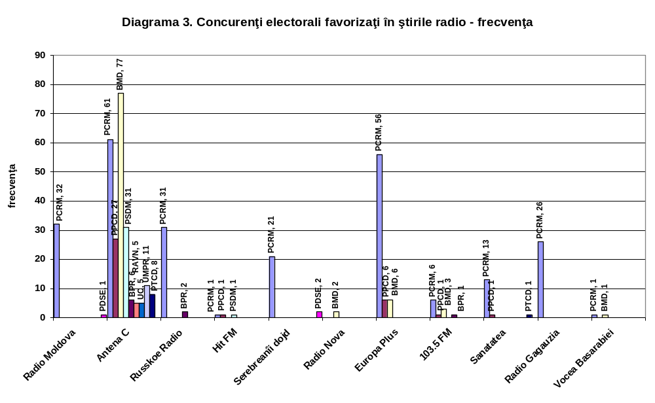
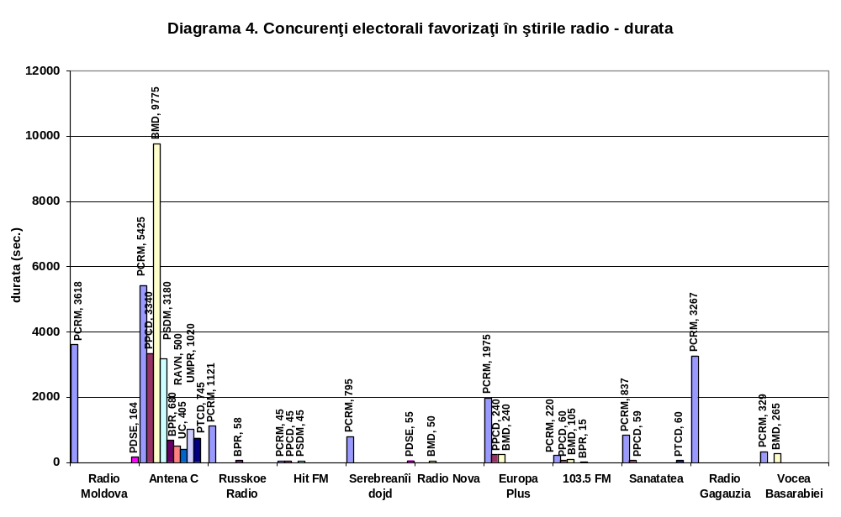

Electoral competitors disfavored in radio news

Radio Moldova disfavored in its news only opposition parties (44 out of 374 pieces of news). Radio Găgăuzia did not broadcast negative news (Diagrams 5-6).

On the other hand, PCRM was mentioned in most news with unfavorable content and/or context broadcast by Antena C (158 of 788 pieces of news). The share of news that disfavored the opposition – BMD, PPCD, PSDM – represented 6.3 percent.

The share of unfavorable news was higher than that of favorable news on Radio Moldova, 11.8 percent, as compared to 8.8 percent, while on Antena C this tendency was reversed, 20.1 percent as compared to 29.4 percent.

The private stations Russkoe Radio, Europa Plus, Hit FM did not broadcast news disfavoring any electoral competitor. Serebreanîi dojd was critical of BMD and PPCD, while Radio Nova, 103.5 FM, Sănătatea broadcast news disfavoring PRCM every 3-4 days (Diagrams 5-6).

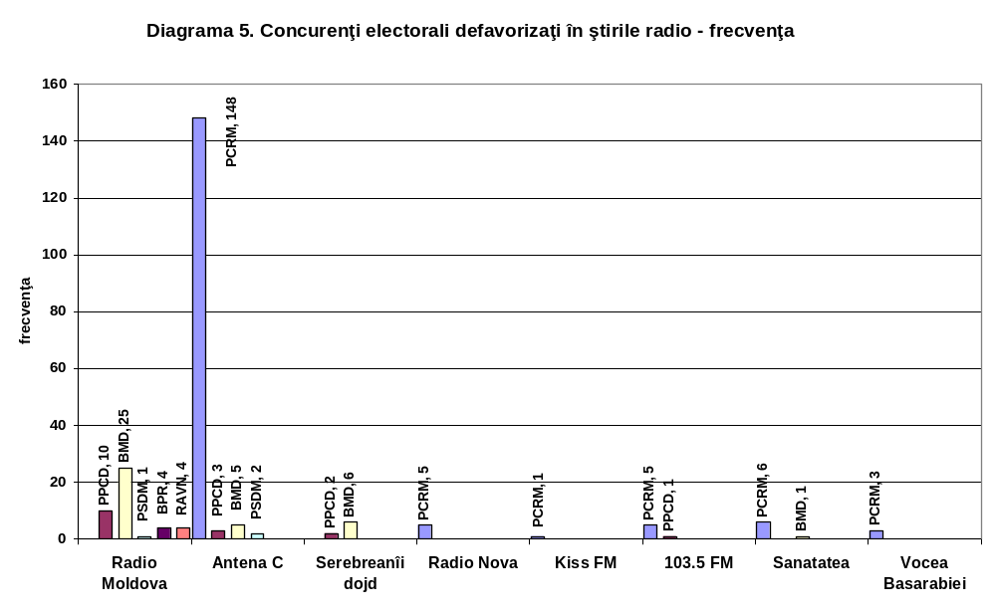
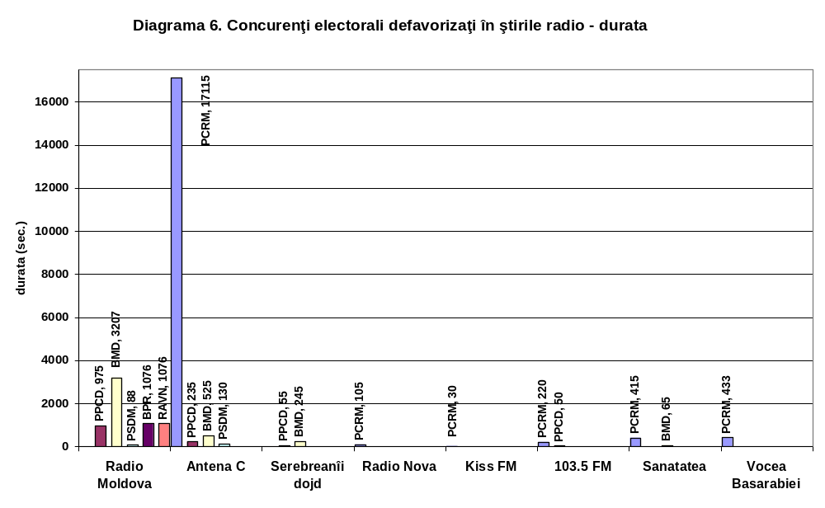

Special electoral programs

Only Antena C, Radio Nova and Vocea Basarabiei offered to the audience debates and interviews with the participation of electoral competitors (Diagrams 7-8). The editorial policy of the public stations Radio Moldova and Radio Găgăuzia seemed to be an unstated tactics of avoiding presenting the electoral competitors to the public.

Diagram 7. Special electoral programs (debates, interviews) -
Frequency
Antena C
50%
Vocea Basarabiei
20%
Radio Nova
30%

Diagram 8. Special editorial programs (debates, interviews) -
Duration
Antena C
42%
Vocea Basarabiei
24%
Radio Nova
34%
Voter education

Radio Moldova broadcast only one voter education program with the duration of 3,300 seconds, and Radio Găgăuzia – none. Antena C broadcast 69 programs, with the total duration of 1,930 seconds (Diagrams 9-10).

Except for Vocea Basarabiei (7 materials) and Sănătatea (1 material), the other private stations did not participate in the voter education.

Table 1. Number of sources in electoral news - %
Diagram 9. Voter education – Frequency
Radio Moldova
1%
Vocea Basarabiei
9%
Sanatatea
1%
Antena C
89%
Diagram 10. Voter education - Duration
Radio Moldova
60.4%
Vocea Basarabiei
4.0%
Sanatatea
0.3%
Antena C
35.3%
 | 1 source | 2 and more sources
Radio Moldova | 50 | 50
Antena C | 40 | 60
Russkoe Radio | 97 | 3
Hit FM | 100
Serebreanîi dojd | 52 | 48
Radio Nova | 95 | 5
Europa Plus | 83 | 17
Kiss FM | 100
Blue Star radio (103.5 FM) | 95 | 5
Sanatatea | 39 | 61
Teleradio Gagauzia | 52 | 48
Vocea Basarabiei | 33 | 67

Sources used

The most often used sources in the news broadcast by Radio Moldova and Antena C were mass media (50.1 percent and, respectively, 29 percent of the total number of source usage cases) and the Central Electoral Commission (15.7 percent and, respectively, 12.4 percent). Radio Găgăuzia referred most often to CEC in its news (25.2 percent) (Table 2).

Antena C used in its electoral news sources from within the competing parties – BMD (8.9 percent), PCRM (7.8 percent), PPCD (4.1 percent), PSDM (3.4 percent), BPR and “Ravnopravie” (under 1 percent). Radio Moldova made reference to BMD in 2.2 percent of cases, to PCRM – 1.7 percent, PPCD – 0.7 percent, and to PSDM – in one case.

Also, Antena C resorted more often to the information issued by the civil society – 122 references (8.1 percent), as compared to 46 (3.8 percent) in the case of Radio Moldova (Table 2).

Table 2. Type of sources used within electoral news - Frequency
 | PCRM | BMD | PPCD | PSDM | BPR | RAVN | PRES | MIN | GUV | APL | EXP | CET | CEC | SO | MED
Radio Moldova | 20 | 27 | 8 | 1 |  |  | 21 | 23 | 34 | 40 | 59 |  | 189 | 8 | 613
Antena C | 120 | 134 | 62 | 52 | 10 | 5 | 26 | 21 | 17 | 49 | 24 | 26 | 187 | 6 | 437
Russkoe Radio | 4 |  |  |  | 2 |  | 7 | 3 | 3 |  | 8 |  | 20 |  | 53
Hit FM |  |  |  |  |  |  | 1 |  |  |  |  |  |  |  | 4
Serebreanîi dojd | 10 | 2 |  |  |  |  | 20 | 13 | 19 |  | 9 | 1 | 36 | 5 | 94
Radio Nova | 1 | 3 |  |  |  |  |  |  |  |  |  |  | 2
Europa Plus | 1 |  |  |  |  |  | 118 | 46 | 55 | 7 | 6 |  | 2 | 6
Kiss FM |  |  |  |  |  |  |  | 2 | 1
Blue Star  (103.5 FM) | 1 |  |  |  |  |  |  |  | 1 | 3 |  |  | 5 |  | 44
Sanatatea |  | 1 | 3 |  |  |  | 22 | 11 | 3 | 1 | 4 | 2 | 3 |  | 56
Teleradio Găgăuzia | 4 |  |  |  |  |  | 2 | 16 | 2 | 31 | 4 |  | 26 |  | 3
Vocea Basarabiei |  | 1 |  |  |  |  | 1 |  |  |  | 1 | 3 |  |  | 1

 | JUD | SOC | DIP | SIN | CCA | POL | BUS | PTCD | PDSE | FG | TRAN | UC | UMPR
Radio Moldova | 7 | 46 | 91 | 2 |  | 2 |  |  | 6 |  | 5
Antena C | 4 | 122 | 131 |  | 1 | 24 | 5 | 13 | 2 | 6 | 2 | 5 | 17
Russkoe Radio | 1 | 3 | 1
Hit FM |  |  | 1
Serebreanîi dojd | 1 | 6 | 48 |  |  | 2 |  |  | 1 |  | 3
Radio Nova
Europa Plus |  |  | 32 |  |  | 6 | 4
Kiss FM |  |  | 7
Blue Star  (103.5 FM) |  | 1 | 2 |  |  | 1
Sanatatea | 1 | 4 | 3 |  |  | 1 |  |  |  | 1
Teleradio Găgăuzia |  | 7 | 6 |  |  |  |  | 2
Vocea Basarabiei |  | 1
PRES – President EXP – Experts CET – Citizens SOC – Civil society, NGOs
MIN – Ministers BUS – Businesspersons MED – Mass media SIN – Trade unions
GUV – Government officials BIS – Church JUD – Judges, attorneys CCA – Broadcaster Coordinating Council
APL – Local public administration POL – Police/Army CEC – Central Electoral Commission TRANS – Transnistria DIP – Foreign diplomats and officials
PCRM – Communist Party
PPCD – Popular Christian Democratic Party
BMD – Democratic Moldova Bloc
PSDM – Social Democratic Party
BPR – Patria-Rodina Electoral Bloc
RAVN –Ravnopravie Movement
PŢCD – Peasants Christian Democratic Party
PDSE – Social Economic Justice Party
UMPR –Patria-Rodina Labor Union
UC – Centrist Union
FG – Independent Candidate Feodor Ghelici

Print media

Public (state) newspapers favored the authorities in the newscasts, followed, with a large difference as concerns the frequency of the news and the granted space, by PDSE, UMPR and BPR. In a negative context, these newspapers mainly presented Democratic Moldova Bloc or PPCD.

Private (non-state) press criticized more the governing party and equally the other electoral competitors. Although these newspapers presented in a positive context mainly BMD and PSDM, however, the amount and frequency of the news favorable to the respective electoral competitors were smaller compared to the same pro-PCRM indices in the state press.

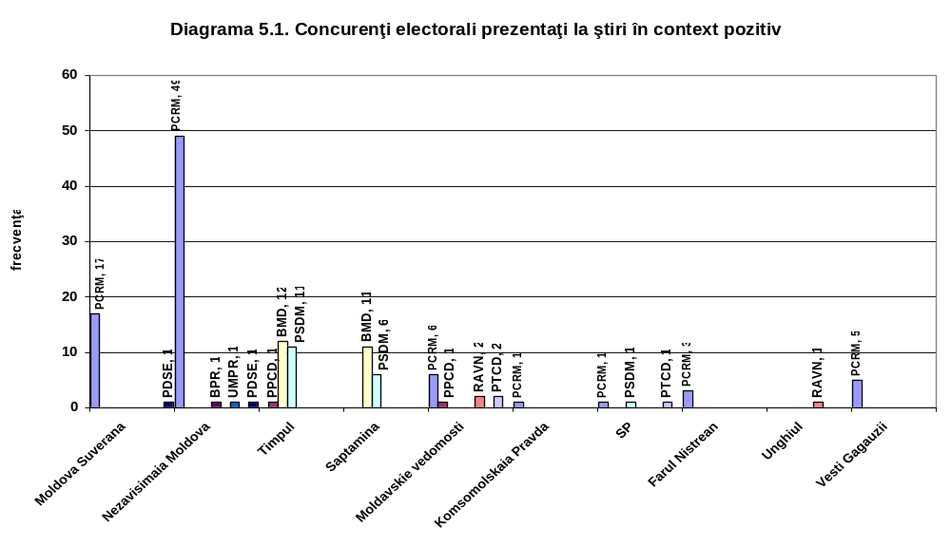

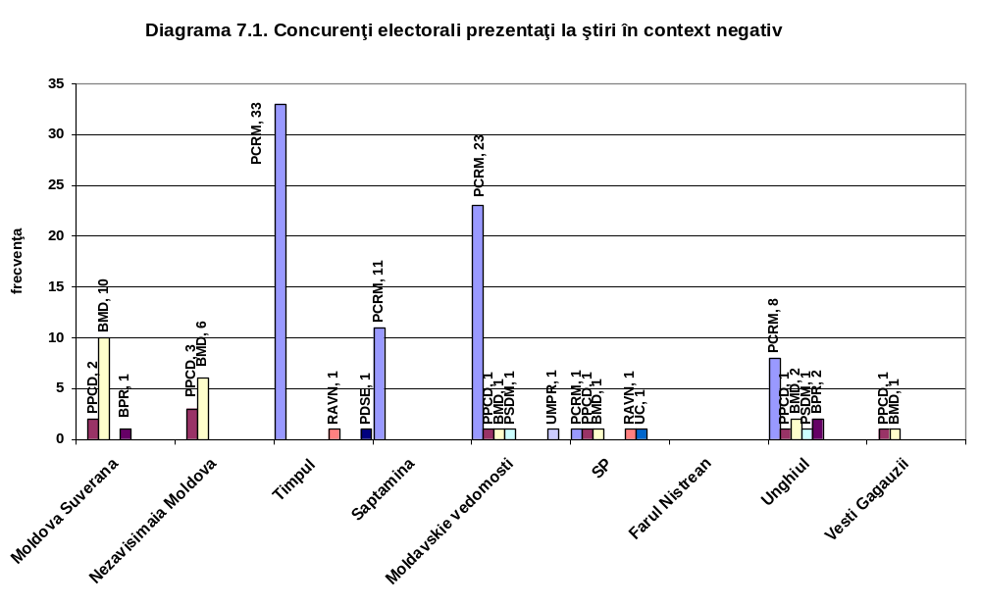
Most articles of opinion on the electoral process were published in the newspaper “Timpul de dimineaţă” (41 percent of the total of such articles), followed by “Nezavisimaia Moldova” (17 percent), “Moldova Suverană” (11 percent), “Săptămîna” (10 percent) and “Moldavskie Vedomosti” (8%). The opinion articles published in “Moldova Suverană”, “Nezavisimaia Moldova” and “Vesti Gagauzii” presented in a negative context only PCRM (rarely – PPCD or BPR). The newspapers “Timpul de dimineaţă”, “Săptămîna” and “Moldavskie Vedomosti” published several opinion articles, presenting in a positive context BMD, PSDM and PŢCD.

Most newspaper space for voter education was provided by the newspaper “Timpul de dimineaţă” – 53 percent of the total space provided for education in the monitored press. It was followed by “Unghiul” (20 percent), „Nezavisimaia Moldova” (13 percent), “Moldavskie Vedomosti” (11 percent).

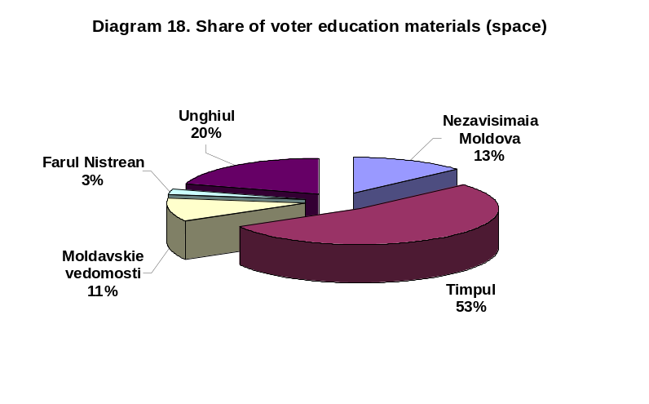
ANNEXES:

- Methodology
- Monitoring period
- Monitoring timetable
- Criteria of selection of media institutions
- Monitored mass media

1. Methodology
What do we monitor?
- News
- Election advertising (airtime)
- Direct speech time
- Opinions
- Special electoral programs (debates etc.)
- Vox populi
- Voter education

Each electoral material is subject to a content and context evaluation to determine whether it is favorable or unfavorable to one or the other candidate. The fact that the content and/or context of a piece of news is positive or negative does not necessarily point to the bias or partisanship of the station having broadcast the news. It is possible that the news favor or disfavor one of the candidates and, nonetheless, are equidistant from a professional perspective. Only when there is a tendency, over a period of time, that one of the candidates is favored or disfavored, will we consider that we are dealing with lack of balance.

Each monitored material is codified depending on its topic, and its sources are identified, codified and accounted. Preference for certain sources, over a period of time, could also indicate an unbalance of coverage in favor of one or another candidate.

2. Monitoring period - 6 January - 6 May 2005 – covers the parliamentary electoral campaign, the post-electoral period as well as the coverage of the campaign for the election of a new President by the Parliament.

3. Monitoring timetable
TV
Monday-Friday
06:30 – 09:00 şi 17:00 – 22:30

Saturday-Sunday
06:30 – 22:30

Radio
Monday-Sunday
06:00 – 24:00

4. Criteria for the selection of media institutions subject to the monitoring:
- Print run/audience/impact
- Type of ownership (state and private)
- Language (Romanian and Russian)
- Coverage (national, local)

5. Monitored mass media:

Print media
Moldova Suverană, Nezavisimaia Moldova, Timpul de dimineaţă, Săptămîna, Komsomolskaia Pravda v Moldove, Moldavskie Vedomosti, SP (Bălţi), Vesti Gagauzii (Comrat), Unghiul (Ungheni), Farul Nistrean (Rezina)

TV
Moldova 1, NIT, Pervîi canal v Moldove, PRO TV, Euro TV Chişinău, TVC 21, RIF TV, TV Bălţi, Blue Star (Bălţi), TV Găgăuzia, Canal X (Briceni), Cvant TV (Cahul)

Radio
Serebreanîi dojd, Radio Moldova, Antena C, Russkoe Radio, Hit FM, Sănătatea (Edineţ), Radio Nova, Europa Plus, Kiss FM, 103.5 (Bălţi), Vocea Basarabiei, Radio Găgăuzia

